Update & Delete Records
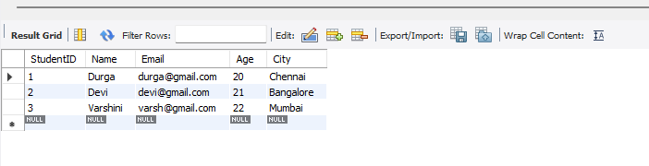

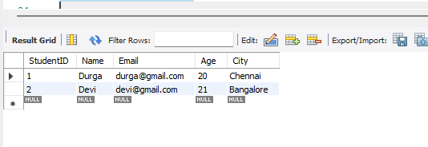
Explanation:
Rahul’s city was updated from Delhi to Bangalore, and the updated records were displayed.
The record of Priya (StudentID 3) was deleted successfully, and the remaining records were displayed.

